19”/2® PWR300 Series
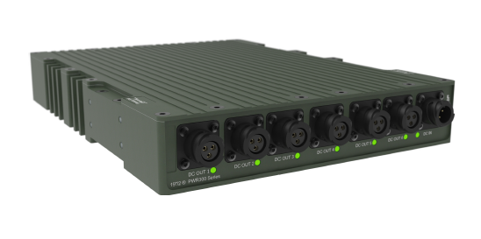

 | PWR301 | PWR311
Power input | 10-32V DC (max 15A) | 10-32V DC (max 15A)
Power output | Pass through  Max 10A per port | Pass through  Max 10A per port
Number of inputs | 1x DC in | 1x DC in
Number of outputs | 6x DC out | 6x DC out
Output protection | 10A mechanical circuit breakers | 10A mechanical circuit breakers
MIL-STD-1275D | No | Yes
Dimensions (WxDxH) | 220 x 182 x 44 mm  (8,7” x 8,2” x 11,9”) | 220x 300 x 44 mm  (8,7” x 11,9” x 1,7”)
Weight | 2 kg | 3.5 kg
Model Comparison

